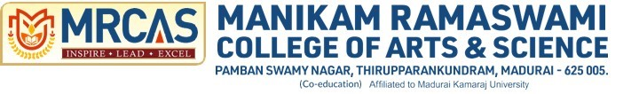

**SOCIAL INTERNSHIP**

**BACHELOR OF SCIENCE**

**In**

**Data Science and Analytics**

**By**

**Meenakshi .K**

**C3S48857**

**Under the Supervision of**

**Dr. G Preetha**

**[Duration : 18th June to 26th June, 2024]**

**Acknowledgement**

EKTA Women's Centre for its unwavering commitment to empowering women and fostering gender equality. Their dedication to providing support, resources, and education has significantly impacted the lives of countless women, helping them to achieve their full potential and contributing to a more inclusive and equitable society.

The EKTA Women's Resource Centre In Madurai, Tamil Nadu, has been a pivotal organization in promoting women’s rights and empowerment since its inception. Known for its dedicated efforts in addressing issues such as gender inequality, violence against women, and economic empowerment, EKTA has been instrumental in fostering a supportive environment for women in the region. The centre offers various programs and services, including legal aid, vocational training, health education, and community outreach, thereby playing a crucial role in improving the lives of countless women in Madurai.

**EKTA resource centre for women**

**Internship report**

**(18.06.24 - 26.06.24)**

The very first day of our internship, we were given introduction about EKTA and it’s origin. EKTA organization was begun in the year 1990. The main purpose of this organization is to empower women and to create a gender discrimination free society where women are valued and given respect. Apart from this, many children were rescued from Tsunami disaster in cuddalore district. It also has another branch at killai. It has also done many other works to spread awareness and educate them .

Day 2

Date : 19.06.24. Day: Tuesday

Ekta is an organization committed to advancing gender equality, empowering women, and supporting women’s rights and welfare. They implement several key initiatives to achieve these goals:

1. **Childline Services in Railways**:

Ekta operates Childline services at railway stations to provide immediate assistance to children in distress. This service is crucial for protecting vulnerable children who may be lost, abandoned, or at risk of exploitation and abuse.

1. **Life Skills Education in Schools:**

Ekta offers life skills education programs in schools to equip students with essential skills for personal development and societal contribution. These programs cover a range of topics, including communication, decision-making, critical thinking, and emotional management, fostering a supportive and empowering environment for young learners

1. **Promoting Gender Equality and Women’s Empowerment:**

Ekta plays a pivotal role in promoting gender equality by advocating for women’s rights and providing support and resources to empower women. Their initiatives aim to create a more inclusive and equitable society where women can thrive.

1. **White Ribbon Campaig:**

The White Ribbon Campaign is one of Ekta’s most prominent programs. It involves participants taking a public pledge to never commit, condone, or remain silent about violence against women. This campaign raises awareness about gender-based violence and encourages community members to take an active stand against it.

Through these efforts, Ekta is making significant strides in fostering a safer, more equitable society for women and children.

Day 3

Date: 20.06.24 Day: Wednesday

A field visit was conducted to the Arapalayam bus stand to perform a safety audit, and a report was compiled based on the observations. The focus of the audit was to assess the safety conditions and identify areas for improvement to ensure the well-being of the public.

Key Observation

1. **Infrastructure Improvements**:

- Upgrade and maintain the physical infrastructure of the bus stand, focusing on repair and renovation of worn-out facilities.

- Install adequate lighting throughout the bus stand to enhance visibility and safety.

2. **Enhanced Security**:

- Increase the number of surveillance cameras and ensure they cover all critical areas without blind spots.

- Deploy more security personnel and improve their visibility and accessibility to the public.

3. **Effective Crowd Management**:

- Improve signage and information dissemination for better navigation and communication with passengers.

- Implement crowd control measures, such as designated entry and exit points and barriers, to manage the flow of people effectively.

4. **Public Amenities Enhancement**:

- Ensure regular cleaning and maintenance of all public areas, especially restrooms and waiting areas.

- Provide facilities for differently-abled individuals to ensure inclusivity and accessibility.

5. **Health and Safety Protocols**:

- Establish clear emergency preparedness measures, including the availability of first aid kits, fire extinguishers, and trained personnel.

- Implement and promote health measures, such as providing hand sanitizers and displaying public health information.

By addressing these observations and implementing the recommended measures, the safety and overall experience at the Arapalayam bus stand can be significantly improved for the public.

Day 4

Date:21.06.24. Day: Friday

A team visited the Arapalayam bus stand to check its safety and wrote a report based on their findings. They looked at various aspects, including infrastructure, security, crowd management, public amenities, and health and safety protocols. Here are the main points:

* Infrastructure Issues
* Security Problems
* Crowd Management Issues
* Public Amenities Issues
* Improve Security
* Better Crowd Management

By addressing these issues and implementing the recommended changes, the safety and overall experience at the Arapalayam bus stand can be significantly improved.

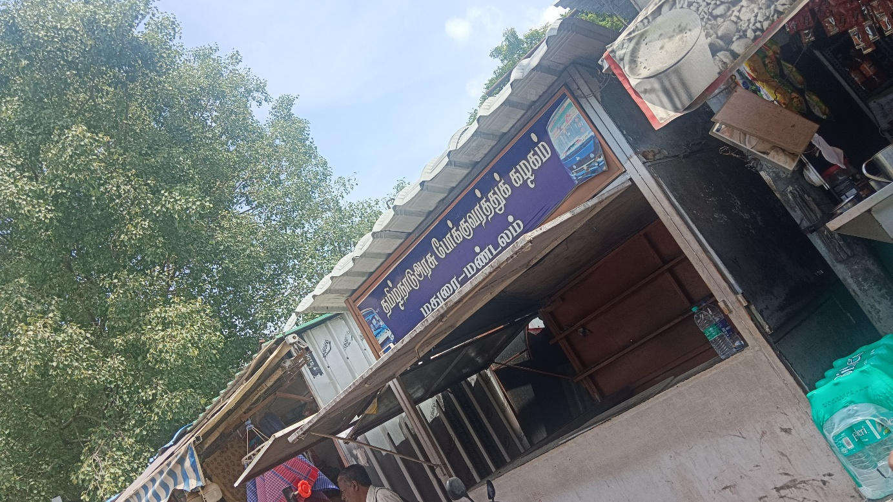

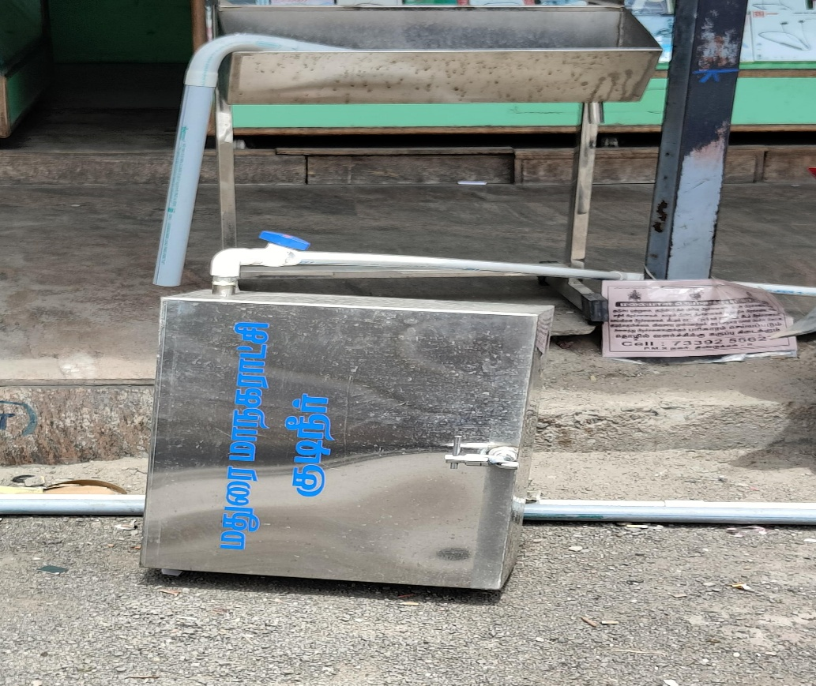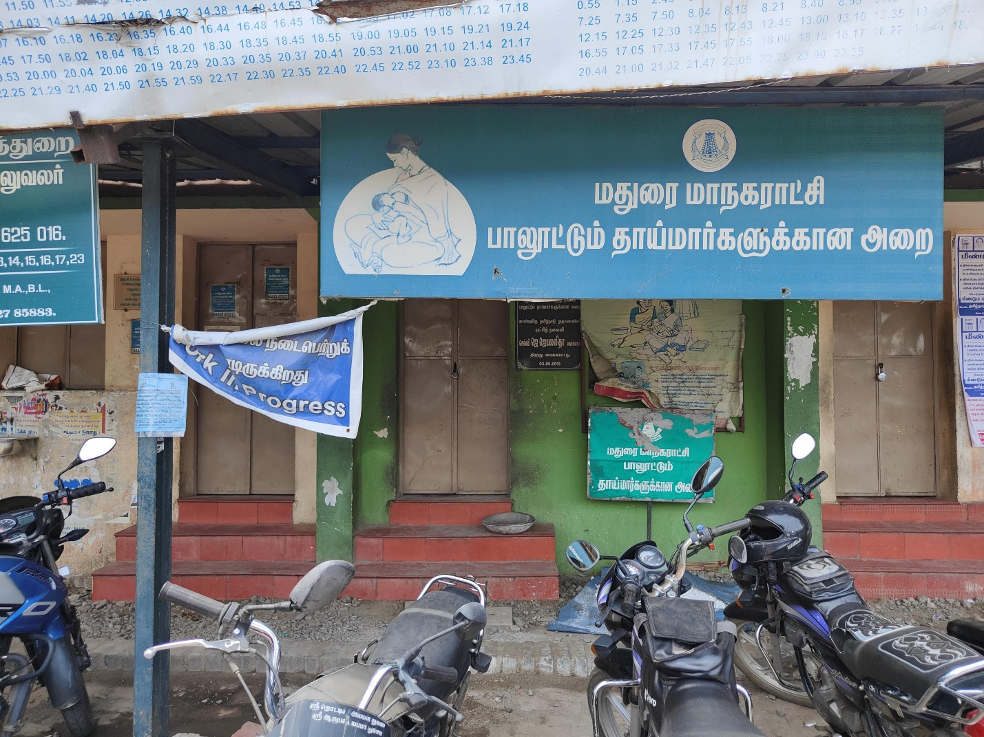

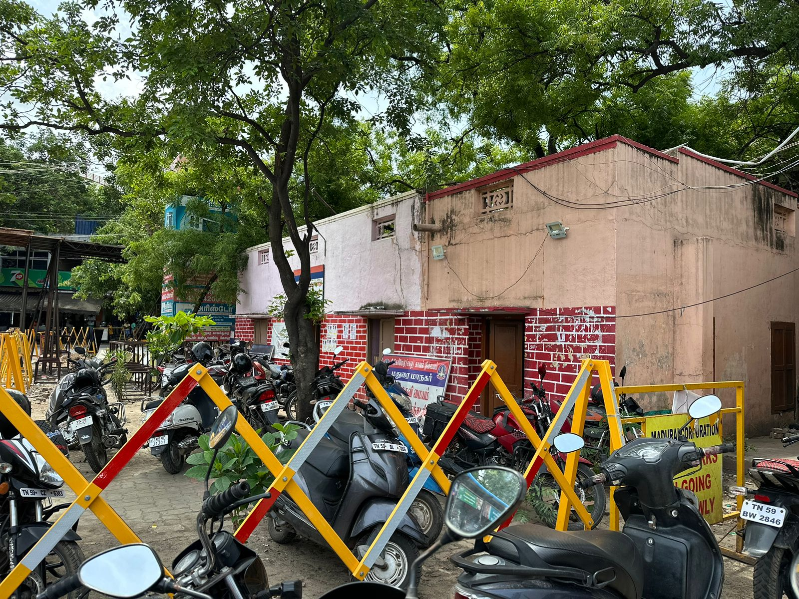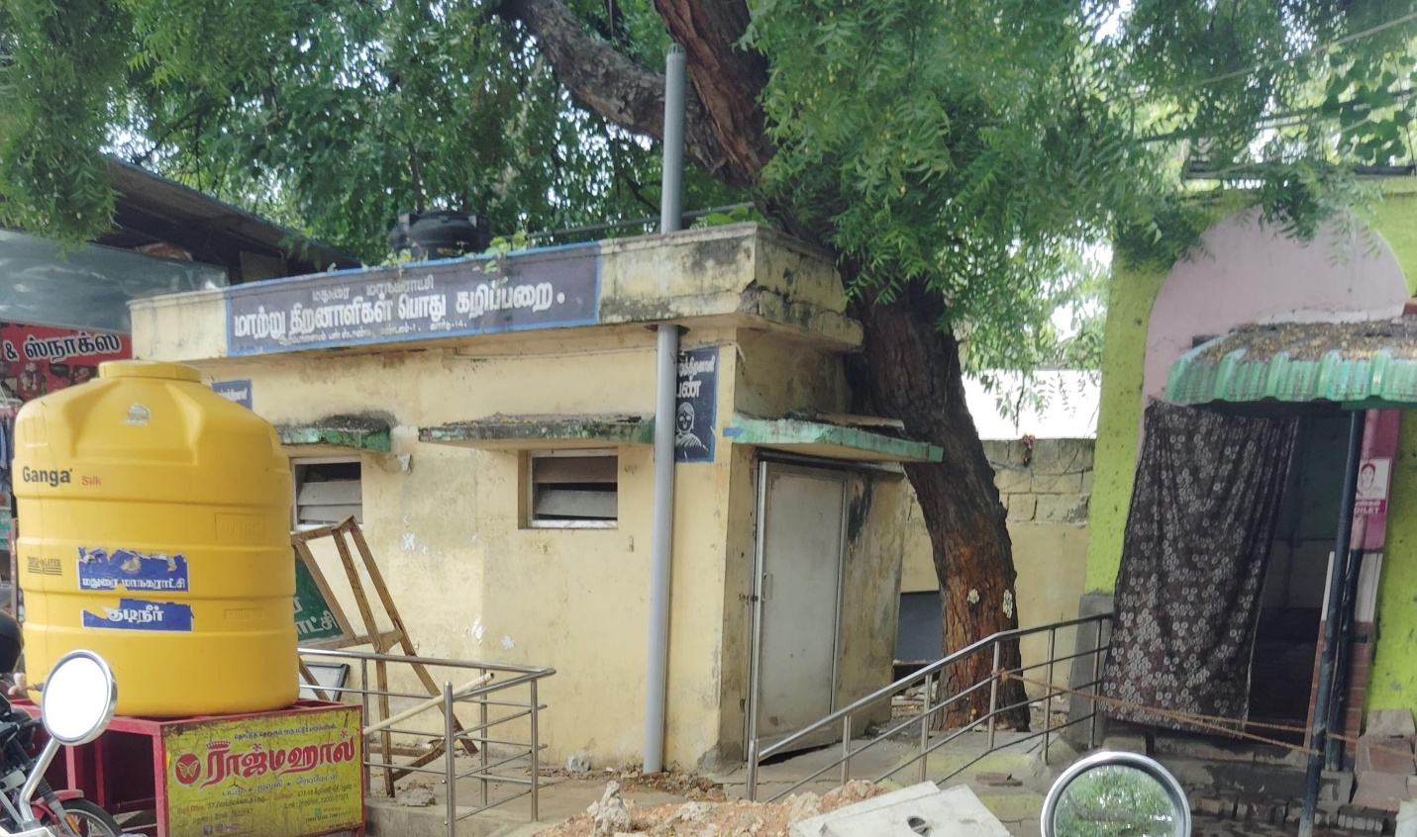

Day 5

Date:24.06.24. Day: Monday

Based on the feedback from mentors, here’s an enhanced version of your safety auditing presentation tailored to Arapalayam, Madurai. Start with a brief introduction to safety auditing and its importance. Then, contextualize it by discussing specific safety challenges and prevalent industries in Arapalayam. Highlight common local safety issues and historical incidents to make the presentation relevant. Incorporate detailed steps for conducting safety audits, emphasizing planning, data collection, analysis, reporting, and follow-up. Finally, include actionable recommendations specific to the local context, and best practices to overcome challenges and ensure continuous improvement. Use local case studies or examples to illustrate points and engage the audience.

Day 6

Date:25.06.24. Day: Tuesday

To enhance your safety auditing presentation based on mentor feedback, integrate additional points and charts focused on Paperbag Day, Youth Day, and Nature Conservation Day. Contextualize safety auditing by discussing Arapalayam, Madurai’s specific safety challenges and prevalent industries. Highlight the relevance of each day: promote eco-friendly practices from Paperbag Day, youth involvement in safety from Youth Day, and environmental conservation from Nature Conservation Day. Include charts showing data on waste reduction, youth participation in safety programs, and environmental hazard management. Conclude by emphasizing

Safety, sustainability ,and continuous

the integration of s improvement practices

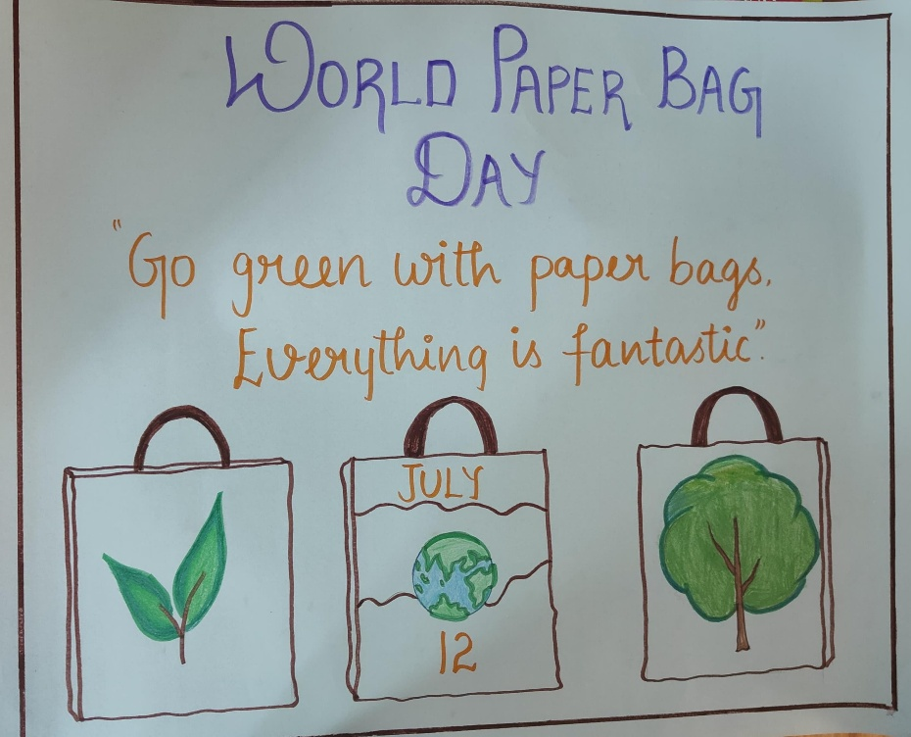

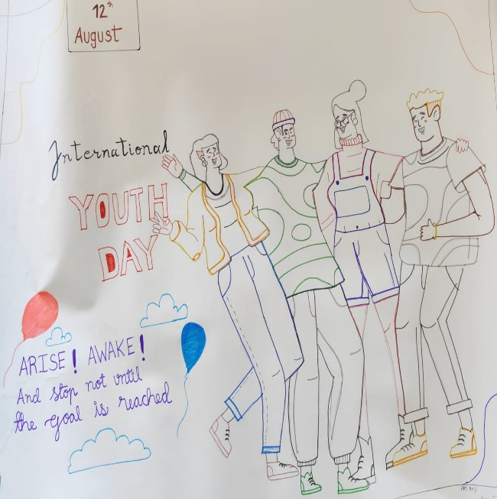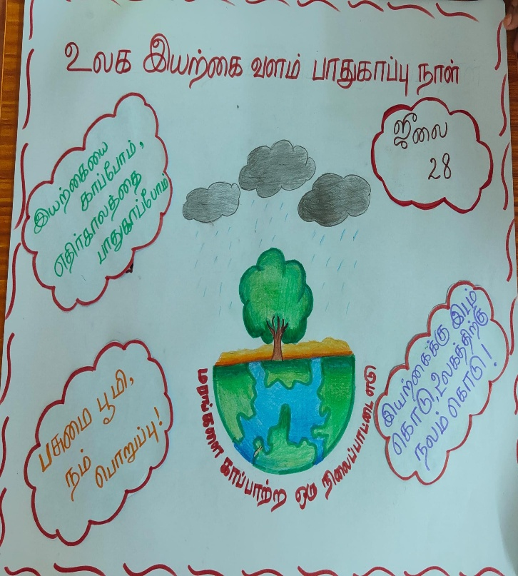

Day 7

Date: 26.06.24. Day: Wednesday

On the final day of my internship at Ekta, we gathered to document a

Detailed report that encapsulated the essence of my journey and

Contributions during this enriching experience. The report highlighted

The various projects I undertook, showcasing the practical skills I

Developed and the challenges I overcame. It also provided a

Comprehensive overview of the industry insights I gained and the

Valuable lessons learned from my mentors and colleagues. Writing

This report was not just a culmination of my efforts over the internship

Period but also a testament to the growth and professional

Development I experienced during my time at Ekta. It was a reflection

Of the dedication, learning, and meaningful connections that defined

My internship journey.